**UNIT:10 | SERVING FOOD AND BEVERAGE**

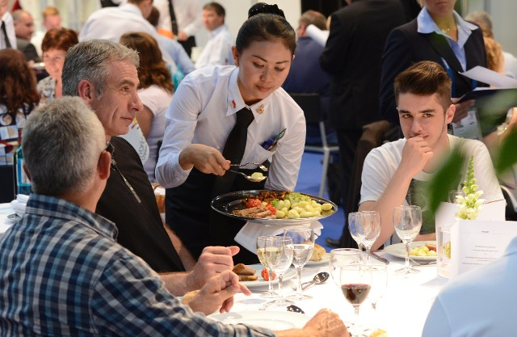

**School: Thaajuddeen**

**Name: Hussain Maain**

**Class: 10-btec**

**Index: 10603**

**The different meal occasions that hospitality organisations cater for (P1)**

* Birthday parties
* Anniversaries
* Private functions
* Dinner
* New year
* Family gathering
* Tea parties
* Weddings
* Business events
* Events for kids
* Romantic meals
* Mother's Day
* Bonfire night
* Picnic
* Halloween

**The factors that influence the use of different food and beverage service styles in different hospitality businesses (P2)**

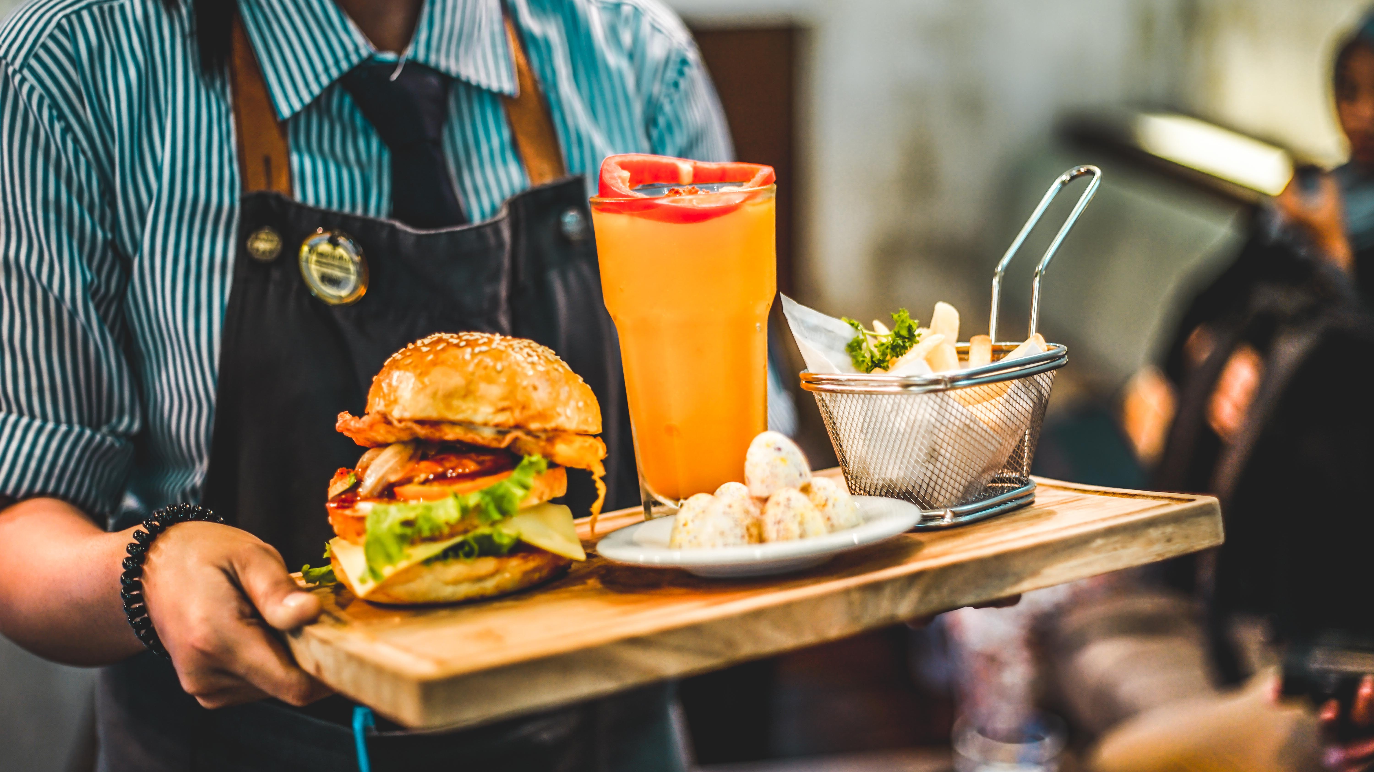

Food:

* Type of establishment
* Location of establishment
* Time available for service
* Service area available
* Type of dishes to be served

Beverage:

* Type of customers
* Type of a drink
* Service equipment
* Time of the service
* Location for the service

**Professional, safe and hygienic practices that should be followed when preparing a food and beverage service area (P3)**

**Professional:**

* Assigning waiters to stations
* Collecting linen for tables and polishing
* Polishing all crockery, cutlery and glassware required

**Safe:**

* Do not wear loose Jewlery. Avoid wrist Jewlery
* Do not work when facing cold, cough, or any other contagious diseases
* Do not smoke or eat tobacco while working

**Hygienic:**

* Wash hands with mild cleansing soap and warm water; not merely with running water
* Avoid cross contamination by using colour-coded chopping boards and knives, storing raw and cooked foods separately
* never cough or sneeze over food, or where food is being prepared or stored

**Professional, safe and hygienic working practices when serving customers (P6)**

**Professional:**

* Don’t let them wait too much and learn how to keep them busy.
* Be as warm and inviting as possible when greeting or talking to customers
* Make sure to be aware of the menu and the specials, and can explain dishes to customers where required

**Safe:**

* Avoid risks of burns from dishes, meals or drinks that are hot
* Wear appropriate personal protective equipment and apparel for the task
* Avoid contact with food surface

**Hygienic:**

* make sure the table is clean and wiped down as well as the chairs or benches
* Hold plates by bottom or at the edges
* Keep fingernails short and clean

**The techniques which can be used to assess the success of food and beverage service (P8)**

* **Check seating efficiency by assessing how well your tables are turning over while still offering quality service.**
* **Divide total sales by the total number of labour hours and compare with your average cost of staff per hour.**
* **Assess profitability of recipes to formulate a menu price that allows for a good profit margin.**
* **Get the measure of employ turnover rate to evaluate affect your current and future customer base.**
* **Get the measure of historical sales to tracks how a restaurant is doing over time.**